

**School of Computer Science and Engineering**

**Faculty of Engineering**

**UNSW Sydney**

**COMP2121 Project:**

**Monorail Emulator User Manual**

by

Omar Al-Ouf & Ihor Balaban

Report submitted as a requirement for the Microprocessors and Interfacing course (COMP2121)

Submitted: October 26, 2018 Student ID: z5037275

z5229133

# Contents

1. Introduction 1

1.1 Board Setup 1

2. Operation 3

References 8

Chapter 1

# Introduction

This paper serves as a user manual of the program implemented for COMP2121 2018 second session’s project.

## Board Setup

Fig. 1 illustrates board setup for program implementation.

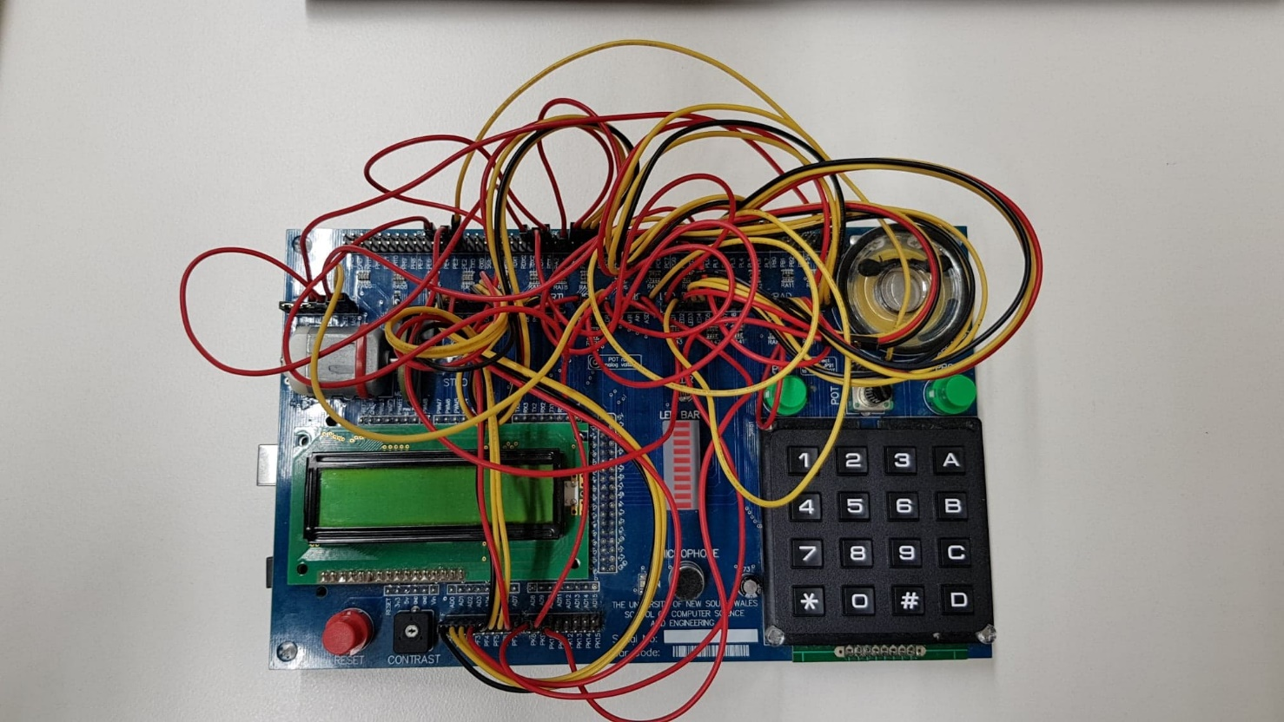

**Figure 1. Board setup.**

The table below shows the general port connections.

**Table 1. Port connections.**

|  |  |
| --- | --- |
| Name | Function |
| LCD | PF0 – PF7 => D0 – D7  PE5 => BL  PA4 => BE; PA5 => RW; PA6 => E; PA7 => RS |
| PB0 & PB1 | RDX3 => PB1  PDX4 => PB0 |
| MOTOR | POT – PE2 – Mot TDX2 – OpO  PA3 – LED  +5V – OpE |
| LED | PC0 – PC7 => LED2 – LED9  PG2 – PG3 => LED0 – LED1 |
| KEYPAD | PL0 – PL3 => C3 – C0  PL4 – PL7 => R3 – R0 |

Chapter 2

# Operation

**Step 1: Entering the number of stations.**

The LCD screen will display as follows: ‘MAX STATIONS’

This step obtains the number of stations, with the maximum being 10. Integer keys input the number of stations. Other keys do not function if pressed, to prevent inputting incorrect data structures.

**Table 2. Number of stations.**

|  |  |
| --- | --- |
| Button | Function |
| 0-9 | Enter number of stations |
| # | Finish inputting and store the number of stations |
| A | Will not work |
| B | Will not work |
| C | Will not work |
| D | Will not work |
| * | Will not work |

When an integer is entered, and the hash key is pressed, the number of stations is stored, and the program continues on to the next step. To handle cases when 0 or 1 stations are entered, a default value of 10 will be stored. On the other hand, if the value is larger than 10, the last digit will be read as the input. For example, the input would be 3 if 123 is typed. Furthermore, if nothing is entered and the hash key is pressed, the number of stations will be considered as 10. There is no limit to the number of digits which can be entered; the hash indicates the end of the input before the program moves on to the next step.

**Step 2: Entering the name of each station.**

The LCD screen will display as follows: ‘STATION 1 NAME’

This step obtains the names of the stations. A station name can be a combination of characters and/or white spaces, with the maximum number of characters being 10.

The chosen procedure for this step follows that of a phonetic keyboard. As seen in Figure 2, Keys A, B, C and D represent the sequence number of the character on a respective number key. A letter must first be pressed before selecting a character key. For example, if the letter ‘D’ is required to be outputted, the A key must first be pressed, followed by 3. Similarly, for output ‘Y’, C must be pressed followed by 9. Pressing a number before a letter key, or selecting D followed by a character which does not have a fourth letter (e.g. 2), will not work. If a white space is required, the star key (*) can be pressed. Keys 0 and 1 have no functionality during this step to prevent inputting incorrect data structures.

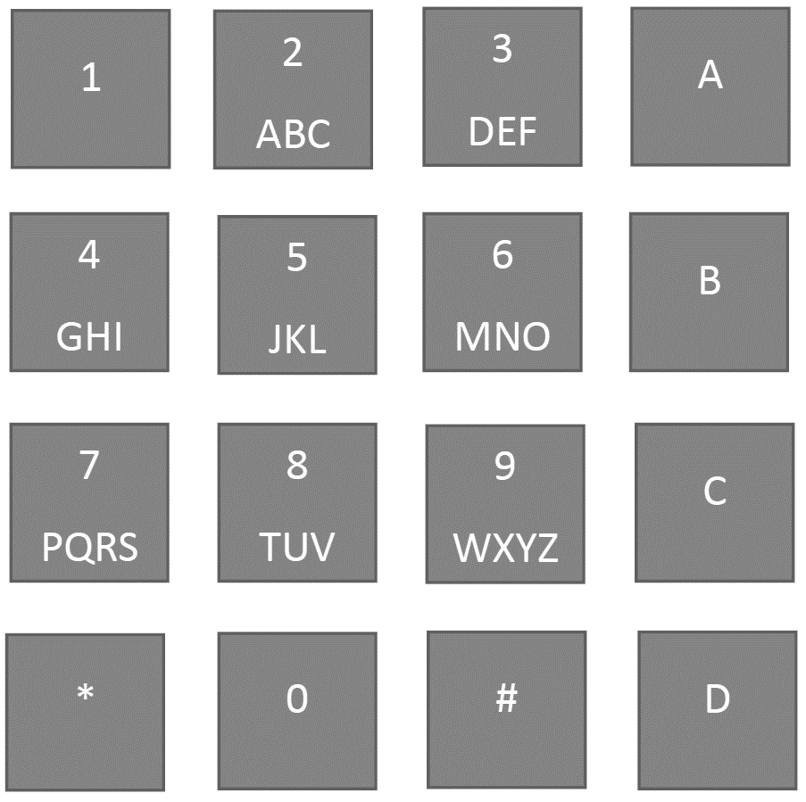

**Figure 2. Phonetic keyboard.**

**Table 3. Station names.**

|  |  |
| --- | --- |
| Button | Function |
| 2-9 | Enter characters |
| # | Finish inputting and store the name of station |
| A | Represents the first character on the number key |
| B | Represents the second character on the number key |
| C | Represents the third character on the number key |
| D | Represents the fourth character on the number key |
| * | White space |
| 0/1 | Will not work |

When the name of a station is entered followed by a hash, it will be stored, and the name of the next station will be requested. The maximum number of characters for a name is 10 – after entering the tenth character, the hash key must be pressed. After storing the name of the last station, the program will continue to the next step.

**Step 3: Entering the travel time from one station to another.**

The LCD screen will display as follow: ‘ST1 TO ST2 TIME’

**Table 4. Travels times.**

|  |  |
| --- | --- |
| Button | Function |
| 0-9 | Enter number of stations |
| # | Finish inputting and store the number of stations |
| A | Will not work |
| B | Will not work |
| C | Will not work |
| D | Will not work |
| * | Will not work |

This step obtains the time for the monorail to travel from one station to the next excluding stops, with the maximum time being 10 seconds.

When a valid number is entered, and the hash key is pressed, the travel time from the current station to the next will be stored and the next travel time will be requested. Entering 0 will store a travel time of 1 second, whereas inputting nothing stores the default value, which is 5 seconds. Any values over 10 will only use the last digit. If nothing is entered before pressing the hash key, the travel time will also be stored as 5 seconds. There is no limit to the number of digits which can be entered. After storing all travel times, the program will continue to the next step.

**Step 4: Entering the stop time.**

The LCD screen will display as follows: ‘MRAIL STOP TIME’

This step acquires the stop time of the monorail at any station, with the minimum time being 2 seconds and the maximum being 5 seconds, as per the specifications [1].

**Table 5. Stop times.**

|  |  |
| --- | --- |
| Button | Function |
| 0-9 | Enter number of stations |
| # | Finish inputting and store the number of stations |
| A | Will not work |
| B | Will not work |
| C | Will not work |
| D | Will not work |
| * | Will not work |

When a valid number is entered, and the hash key is pressed, the time that the monorail stops at a given station will be stored. Entering a 0 or 1 will store the minimum time (2), whereas entering a time larger than 5 will store the maximum (5). If more than 2 digits are entered, the last digit will be regarded as the input. If nothing is entered before pressing the hash key, the stop time will be stored as 5 seconds. There is no limit to the number of digits which can be entered; the hash indicates the end of the input, before the program continue to the next step.

**Step 5: Waiting for a few seconds before the monorail starts travelling.**

The LCD screen will display as follows: ‘CONFIG COMPLETE WAIT’ and then ‘NEXT STATION…’

After waiting for 5 seconds, the motor will begin to travel by starting to spin at a speed of 60 revolutions per second. During this step, the screen will constantly display the name of the next station.

PB0 and PB1 simulate a tourist getting off or on at the next station. If one of them is pressed, the monorail will stop at the next station with the stop time registered before continuing. Whenever the monorail is stopped, two LEDs will blink at a frequency of 3 Hz.

The hash key simulates the case where the monorail stops half way between two stations. When the hash key is pressed again, the monorail will continue travelling from where it left off.

# References

1. Wu, H. (2018). COMP2121 Microprocessors and Interfacing Notes. Accessed 17 Oct. 2018, from WebCMS3 CSE UNSW.